4.2 Using Fig. 4.70, design a problem to help other students better understand linearity.

Although there are many ways to work this problem, this is an example based on the same kind of problem asked in the third edition.

Problem

Find v_{o} in the circuit of Fig. 4.70. If the source current is reduced to 1 μA, what is v_{o}?
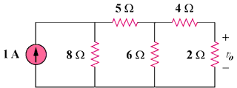

Figure 4.70

Solution

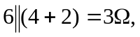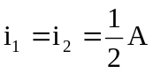
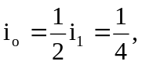 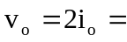 0.5V
5 Ω
4 Ω
i₁
6 Ω
2 Ω
i_{o}
8 Ω
i₂
1 A

If i_{s} = 1μA, then v_{o} = 0.5μV

